REPORT FOR: | PERFORMANCE & FINANCE SUB-COMMITTEE
Date of Meeting: | 20th January 2020
Subject: | Children and Families Services Complaints Annual Report 2018/19
Responsible Officer: | Paul Hewitt, Corporate Director People Services
Scrutiny Lead Member area: | Councillor Jerry Miles  Councillor Janet Mote
Exempt: | No
Enclosures: | No

Section 1 – Summary and Recommendations

This report sets out the statutory Children and Families Services Complaints Annual Report for 2018/19.

Recommendations:
None. For Information purposes only.

Section 2 – Report

Financial Implications
There are no specific budget issues associated with this report. All payments are agreed by Service Managers and are funded within existing budgets.

Performance Issues
There are no specific particular performance issues associated with this report.

Environmental Impact
N/A

Risk Management Implications
Risk included on Directorate risk register? No

Separate risk register in place? No

Equalities implications
N/A

Corporate Priorities
The Council’s vision:
Working Together to Make a Difference for Harrow

Build a Better Harrow

Be More Business-like and Business Friendly

Protect the Most Vulnerable and Support Families

Annual Complaints Report for Children
and Families Services 2018/19

Section | Contents
1 | Executive Summary
2 | Summary of Activity
3 | Outcomes for key actions in 2018/19
4 | Priorities for 2019/20
5 | Stage 1 Complaints
6 | Stage 2 Complaints
7 | Stage 3 Complaints
8 | Ombudsman (LGO) Complaints
9 | Escalation comparison over time
10 | Remedy payments
11 | Mediation and Alternative Dispute Resolution
12 | Joint NHS and social care complaints
13 | Learning Lessons/Practice Improvements
14 | Compliments
15 | Equalities Information
16 | The Complaints Process explained

1 | Executive Summary:  There were some 194 “transactions” within the statutory complaints process during the year, i.e. representations, formal complaints, members enquiries and referrals to the Local Government Ombudsman. Given the nature of some of the work undertaken, such as child protection and looked after children, it is positive that numbers of complaints are so minimal. During 2018/19:  - There were 3727 children who were considered to be children in need (CIN) throughout 2018/19 of which 53% were male and 47% were female. The ethnic breakdown is predominantly BME with approx. a quarter being of white ethnicity. On the last day of the year (31st March) a total of 1,820 children were receiving a service from Social Care with the rest having ceased throughout the year.  - A total of 2,518 referrals were received in 2018/19 by Children’s Social Care with the most common referral source being Police and Schools both accounting for 54% of referrals received. The service completed 2,421 assessments.  - A total of 1073 child protection investigations were initiated in the period with 373 leading to an initial child protection conference.  - There were 571 Child Protection Plans (CPP) active at some point during 2018/19, 339 new plans were started & 291 ceased during the year. At the time of 31st March 280 children were being supported and monitored through a Child Protection Plan  - A total of 281 children were looked after (CLA) at some point during 2018/19, during the year 124 children became newly looked after and 112 stopped being looked after. On 31st March Harrow had 169 looked after children.  - At 31st March 2019 Harrow had 65 approved fostering households offering 120 placements.  - During 2018/19 about 8200 families accessed the Cedars and Hillview Early Support hubs and 335 young people accessed the Wealdstone Early Support hub.  Children’s Social Care Teams continued to attract the most complaints (80%). This reflects the nature of the statutory social work undertaken by these services, where difficult decisions regarding children and their families sometimes leads to necessary actions which are unpopular with service users.  This report contains both positive messages and indications of areas needing more work.  - Of particular note is the high level of representations (67) which were potential statutory complaints but were resolved/actioned informally. This is significant in showing that the Council is able to listen to concerns expressed and act promptly to resolve them. Whilst this is positive in terms of the service users’ experience, it also endorses that early resolution is more cost effective for the Council by avoiding escalation with associated costs of any investigations  - The proportion of Stage 1 complaint responses sent within timescales has decreased to 89% in 2018/19, from 94% in 2017/18. This is primarily due to an increase of overall transactions throughout the year but still above the target of 85%. The Complaints Service did not have a Complaints Officer in role from November 2018 to January 2020 (due to secondment/interim role requiring the position to be kept open) which has impacted the services ability to perform at full capacity.  - The relative escalation rate of complaints between the stages of the complaints process is low and reflects the successful efforts made by officers to understand and address concerns when they arise as complaints and representations. Escalation of all initial representations and Stage 1 responses to the next formal Stage (2) was 15%. This means around 85% of representations and formal complaints are resolved with the first initial response from the Council demonstrating the quality of first attempt resolution.  - Key actions that were set for 2018/19 in the previous year have been met.
2 | Summary of Activity
2.1 | Overall Complaint Activity:  Between 1 April 2018 and 31 March 2019 the Council received:
- 67 representations i.e. potential statutory complaints that did not lead to a formal complaint;

- 51 statutory Stage 1 complaints;

- 18 Stage 2 complaints;

- No (zero) Stage 3 complaint received (no panel hearings);

- Six formal Local Government Ombudsman (LGO) complaints.

Additionally, there were 52 MP and Councillor enquiries managed by the Complaints Team. In comparison, 36 enquiries were received last year.

Table 1: Number of Complaints by Service area: April 2018 to March 2019

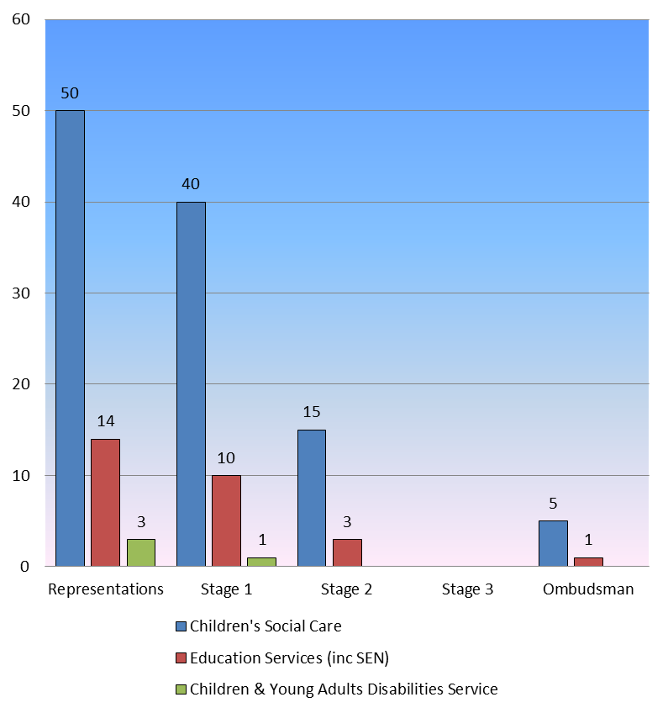
 | Number of Complaint Transactions by Service area: April 2018 - March 2019
 | Service Area |  |  |  | Representations |  |  |  |  |  |  | Stage 1 |  |  |  |  | Stage 2 |  |  |  |  |  |  | Stage 3 |  |  | Ombudsman |  |  |  |  |  |  | Total
 | Children’s Social Care |  |  |  | 50 |  |  |  |  |  |  | 40 |  |  |  |  | 15 |  |  |  |  |  |  | 0 |  |  | 5 |  |  |  |  |  |  | 110
 | Education & Commissioning |  |  |  | 14 |  |  |  |  |  |  | 10 |  |  |  |  | 3 |  |  |  |  |  |  | 0 |  |  | 1 |  |  |  |  |  |  | 28
 | CYAD |  |  |  | 3 |  |  |  |  |  |  | 1 |  |  |  |  | 0 |  |  |  |  |  |  | 0 |  |  | 0 |  |  |  |  |  |  | 4
 | Total |  |  |  | 67 |  |  |  |  |  |  | 51 |  |  |  |  | 18 |  |  |  |  |  |  | 0 |  |  | 6 |  |  |  |  |  |  | 142
Key message: Overall the picture suggests a continuation of high quality investigative and governance standards.

Analysis: During 2018/19 there was a slight decrease in the number of formal Stage 1 complaints received (a reduction of six from the previous year). However, there was an increase in representations (67 in comparison to 57 last year) which shows an increased willingness to provide solutions via informal means which are usually faster and more direct.

As with previous years, the majority of received transactions (both representations and formal complaints) are via Children’s Social Care (80%).

There were 18 Stage 2 complaints received. This represents an escalation rate of 31% of all Stage 1 complaints and 15% escalation of all initial transactions. No (zero) complaints progressed to a Stage 3 panel hearing.

There were six new LGO referrals within the year. Details of these cases are discussed further in the LGO section below.

 | Table 2: Comparison of Complaints over the last 3 years
 | 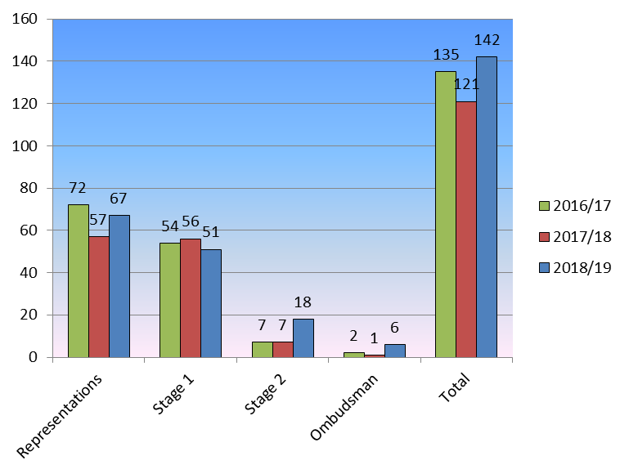
 |  | Representations |  |  |  |  | Stage 1 |  |  |  |  |  |  | Stage 2 |  |  |  |  |  | Stage 3 |  |  |  |  |  | Ombudsman |  |  |  |  |  |  | Total
 | 2018/19 | 67(47%) |  |  |  |  | 51(36%) |  |  |  |  |  |  | 18(13%) |  |  |  |  |  | 0(0%) |  |  |  |  |  | 6(4%) |  |  |  |  |  |  | 142
 | 2017/18 | 57(47%) |  |  |  |  | 56(46%) |  |  |  |  |  |  | 7(6%) |  |  |  |  |  | 0(0%) |  |  |  |  |  | 1(1%) |  |  |  |  |  |  | 121
 | 2016/17 | 72(53%) |  |  |  |  | 54(40%) |  |  |  |  |  |  | 7(5%) |  |  |  |  |  | 0(0%) |  |  |  |  |  | 2(2%) |  |  |  |  |  |  | 135
Analysis: There was an increase in the number of total complaints or ‘transactions’ in 2018/19 (142) compared to 2017/18 (121). This was mainly due to a higher number of informal representations (an increase of 10 from the previous year) and higher number of Stage 2 and LGO referrals.

This was while the number of formal Stage 1 complaints received dropped from last year (51 as opposed to 56). This shows that more disputes are being resolved without involving the formal process.

Escalations beyond Stage 1 have remained low in line with previous years.

Key message: Previous research (e.g. Jerry White, Local Government Ombudsman & Steve Carney, Head of Complaints, CQC) has suggested that Councils with high levels of Stage 1 complaints/representations tended to receive good performance ratings and demonstrated a willingness to hear concerns, address them and improve services as a result.

Key action: To attempt to maintain a balance of representations against actual complaints, as this demonstrates good early resolution for service users.

3 | Outcomes for key actions in 2018/19
All of these outcomes have been met or are currently being progressed.
The timeline of responses was above the 85% target.
Improvements have been made by working more closely with Team Managers who have helped to drive improvements in performance. Trends in cases and escalations have been consistently monitored in weekly catch up meetings by the Complaints Team and as part of quarterly improvement board reports. The Complaints Service also continually directly speaks to Managers, Heads of Service and Directors to ensure a constant line of feedback and complaint resolution and prevention based suggestions and solutions.
The Complaints team also offered more one to one sessions for staff members in handling complaints and reflective discussions with managers who were involved in complaints received to manage future situations where complaints may arise. This work has likely fed into the reduced amount of formal complaints received in this area.
The complaints literature and communications are currently being reviewed to be updated in 2019/2020.
4 | Priorities for 2019/20:
- To ensure that on time Stage 1 complaint response rates continue to exceed the target of 85%

- To continue the core offer of training for front line staff and managers on complaint handling

- To update and finalise complaints literature and communications.

5 | Stage 1 Complaints:
5.1 | Stage 1 Complaints Overall Activity  Table 3  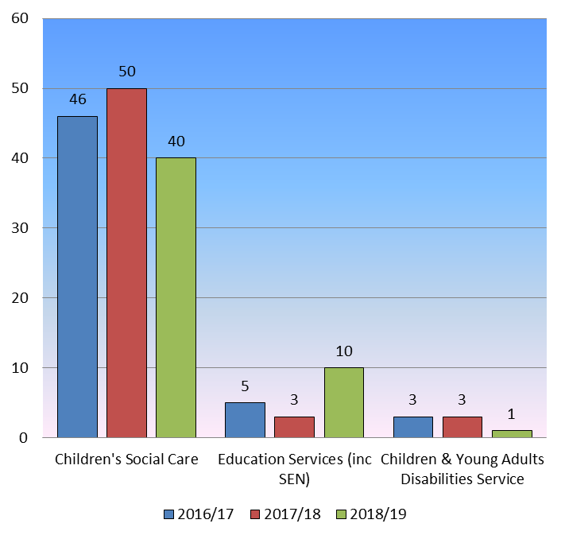
 | Stage 1 Complaints Received
 | Education & Commissioning  Children’s Social Care  CYAD  Total |  |  |  |  |  |  |  |  |  |  |  |  |  |  | 2016/17  5  46  3  54 |  |  |  |  |  |  |  |  | 2017/18  3  50  3  56 |  |  |  |  |  |  | 2018/19  10  40  1  51
Key message: Almost inevitably Children’s Social Care attracts a higher level of complaints. The data below will evidence the majority of complaints are from parents/family members. As the “nature of complaints” section will demonstrate below, many complaints arise from parents having a negative view of social care intervention as this will often involve some assessment of their parenting or family relationship.

However, in 2018/19, there was an increase in complaints with respect to Education and in particular, SEND. This is likely attributed to the increase in SEN students overall and may indicate that this area may continue to present more complaints in future in line with national trends.

“The number of publics with special education needs (SEN) has increased for a third consecutive year to 1,318,300 in January 2019 representing 14.9% of the total population” – Special Education Needs in England Department for Education

Children’s Social Care is child focused and based on statutory duties which can be at odds with the initial expectation of Children’s Services involvement from parents. However, Children’s Social Care has seen a decrease since last year likely due to additional work around informally resolving complaints by Children’s Services.

There were 52 MP and Councillor enquiries managed by the Complaints team, which is a significant increase from 36 in the previous year. MP and Councillor enquiries varied greatly in nature and it is not possible to determine if they would have actually led to a formal complaint. Due to this variation, it also allows responses to queries such as asking about free school meals etc. which would not necessarily come under any complaints procedures. This ensures the Complaints Service are able to assist with responses and resolutions to a wide area of issues beyond the usually defined complaint remits.
5.2 | Stage 1 Response Times
Table 4

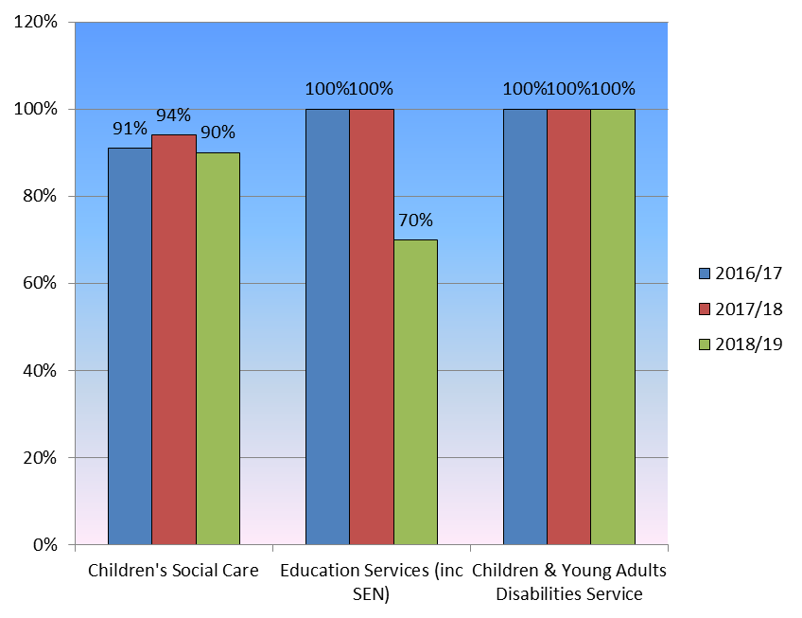

Key message: There has been a decrease in the level of Stage 1 complaints completed on time during 2018/19 compared to the previous year. Education Services had a particular drop as there were a few in progress complaints at the same time as an Ofsted inspection. The priority was the inspection and as such some responses were delayed.

The overall level of on time complaints during 2018/19 was 89%. The primary reason for the decrease is the overall increase in transactions (and member enquiries), in particular the level of Stage 2 and LGO referrals which often require a significant amount of preparation and investigation to allow for a higher quality level of response.

Analysis: On time response rates decreased this year but were still above the 85% target. The Complaints Service values that responses are provided with adequate investigation and preparation time and this will always be kept as a priority.

Key action 1: To continue to meet and exceed the 85% local target timescales for on time Stage 1 complaints throughout 2019/20.

5.3 | Stage 1: Nature of Complaints
Table 5

Nature of Stage 1 Complaints from Young People 2018/2019

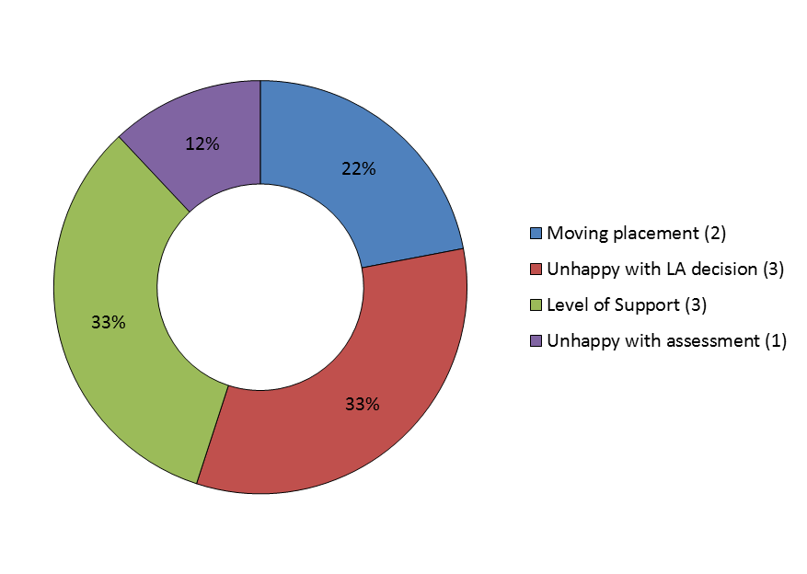
Complaints Examples from Young People
Moving Placement
Did not want to move placement due to connections made in current area
This type of complaint will usually be due to the young person having settled into a placement and surrounding area. Usually sensitive and honest conservations are required to help both young person and services reach an understanding which values young person’s feelings but also ensure their best interests are promoted.
Level of Support
Unhappy that CS would not pay for requested £730 fridge
Young people require support with a wide range of issues from books for university to appliances to within their home. Sometimes a young person may be unhappy with not getting specifically want they want which presents the difference between fulfilling a need and fulfilling a want.
Unhappy with LA decision
Not being accommodated under s20 of the Children Act
At times the local authority will make a decision based on policy, procedure or statute/statutory guidance. A young person may raise their objections to this via the complaints procedure.
Unhappy with assessment
Did not like how age assessment was carried out as well as outcome
An assessment can directly impact the level of support a young person may receive so they are able to formally raise concerns about how an assessment has been carried out.
Analysis – As noted in the previous year’s report, young people tend to raise more practical complaints usually based around managerial decisions with reference to their living or financial circumstances which their social worker usually does not have the authority to resolve individually. This trend has not changed in 2018/19.
Table 6

Nature of Stage 1 Complaints from Parents/Guardians and Relatives 2018/2019

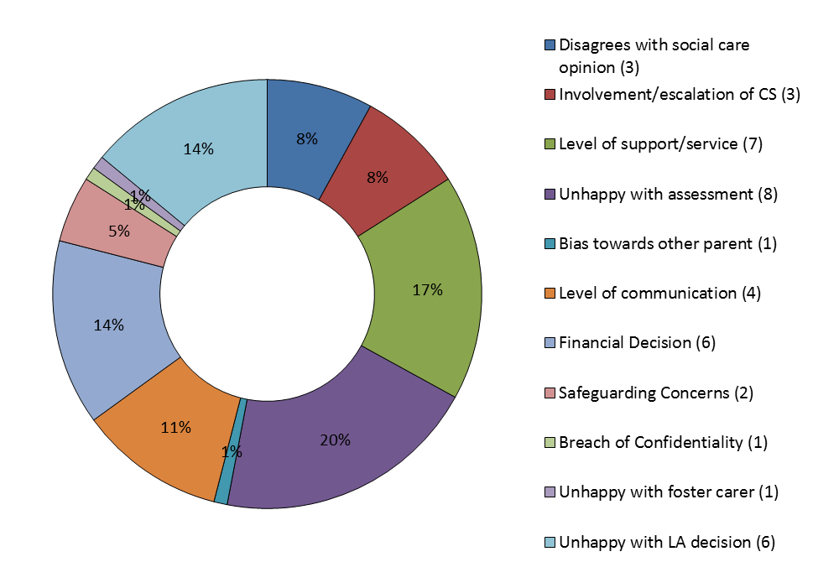
Complaints Examples from Parents/Guardians and Relatives
Disagrees with Social Care Opinion
This category has the greatest number of complaints last year with 14. This has now dropped to three and this is likely due to dealing with these type of complaints more informally (e.g. with a manager calling the individual to help address their concerns) as the next section will evidence.
An example of this complaint is:
Unhappy that social worker has considered alcohol consumption in their opinion of parent
Involvement/escalation of Children’s Services
This category contains complaints where the parent or involved family feel the level of involvement of social care is not justified and often want the case to be closed as an outcome. As above, this has dropped with respect to formal complaints due to Children’s Services working with the complaints service to address these concerns informally which often involves helping parents/family understand the importance and statutory nature of children’s safeguarding work. An example of this complaint was:
Section 47 process should not have occurred or initiated – family communicated that can manage internally
Level of support/service
These complaints normally are from the perspective that the local authority is not doing either enough or not doing specifically what the family would like as support.
An example of this complaint is:
Requesting that local authority provides for a (non looked after) child beyond 18
Unhappy with assessment
Parents or family members who are unhappy with the contents of an assessment (e.g. social work assessment) often raise this via the formal complaints route to address these. An example of this is:
Disputing the inclusion/discussion of historic allegations with respect to a risk assessment

Bias towards other parent
Children’s Services are often in a position where they have to work with parents who are in a difficult or even acrimonious relationship – as such one parent may perceive bias from Children’s Service towards the other:
Feels that Children’s Services have a preference for the paternal side of family
Level of communication
Families can often have expectations for when they are meant to receive a callback or correspondence which if not met, can lead to a complaint.
Unhappy with not providing EHC plan when it was expected
Financial Decisions
Formal complaints can be raised where the local authority has either not satisfied a request for funding/monies or not provided to the level that the family were expecting or wanting:
Requesting private funding package of child therapy
Safeguarding Concerns
There is where a parent/family member may feel not enough is being done by Children’s Services usually due to how they negatively perceive the individual who has parental responsibility or contact with child:
Stating that Children’s Services should be taking further measures against their former partner due to safeguarding concerns
Breach of Confidentiality
An individual may be unhappy how certain information or correspondence may have been shared by Children’s Services:
Unhappy that social worker spoke to health service in carrying out their duties
Unhappy with foster carer
An individual may see the actions of a foster carer and the local authority as being linked:
Did not like how foster carer spoke to them
Unhappy with LA decision

This can be a wide ranging area but is often regarding some kind of decision made by a local authority team or employee that can impact a family:

Unhappy that LA employee made safeguarding referral about their child without consulting them
Analysis – While the above shows a varied basis of complaints, it shows that parent/guardians/family members are using the complaints procedure as a means of challenging or addressing issues they may have with local authority support, financing, decisions etc. while formal complaints which are normally based around perceptions of Children’s Services have reduced in comparison to last year.
This suggests that the formal process is mainly being used to challenge decisions or local authority documentation (such as assessments) and disagreements about social care opinion or involvement are being addressed more informally.

Nature of representations 2018/19 – Table 7

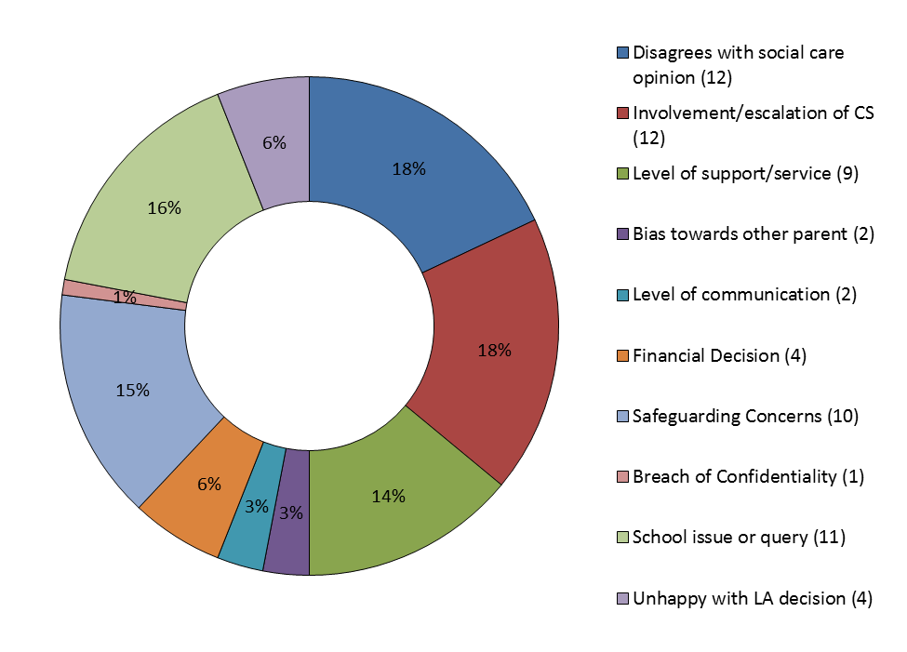
Analysis – As discussed above, these representations that were resolved informally took on a large number of “perception/disagreement” complaints. I.e. ones where family members were unhappy with what social workers were saying in their professional opinions or due to them being involved at all. These alone made up 36% of all representations.

The representation mechanism was also used to address any safeguarding concerns that were raised via the Complaints Services or where the assistance of our service was sought in responding to these particular concerns.

Lastly, schools admissions queries that were raised via the Complaints Service were usually resolved directly via our Admissions Team which is the correct process.

5.4 | Stage 1: Complaints Outcomes
 | Table 8
 |  |  |  | Not Upheld  18/19 17/18 16/17 |  |  |  |  |  | Partially Upheld  18/19 17/18 16/17 |  |  |  |  |  |  |  |  |  |  |  |  | Upheld  18/19 17/18 16/17 |  |  |  |  |  |  |  | Total  18/19 17/18 16/17
 | Education & Commissioning |  |  | 9 2 3 |  |  |  |  |  | 1 0 2 |  |  |  |  |  |  |  |  |  |  |  |  | 0 0 0 |  |  |  |  |  |  |  | 10 2 5
 | Children’s Social Care |  |  | 33 41 29 |  |  |  |  |  | 13 7 13 |  |  |  |  |  |  |  |  |  |  |  |  | 1 2 4 |  |  |  |  |  |  |  | 47 50 46
 | CYAD |  |  | 1 2 2 |  |  |  |  |  | 0 1 1 |  |  |  |  |  |  |  |  |  |  |  |  | 0 0 0 |  |  |  |  |  |  |  | 1 3 3
 | Total |  |  | 43 45 34 |  |  |  |  |  | 14 8 16 |  |  |  |  |  |  |  |  |  |  |  |  | 1 2 4 |  |  |  |  |  |  |  | 58 55 54
 | Total of overall Stage 1 outcomes, by percentage |  |  | 74% 82% 63% |  |  |  |  |  | 25% 14% 30% |  |  |  |  |  |  |  |  |  |  |  |  | 1% 4% 7%
Analysis: Managers and staff within service areas and the Complaints Service have worked towards a more balanced and open approach to complaints, where concerns from service users are recognised and receive appropriate responses. This includes the need to listen to complainants and adopt a less defensive approach when reflecting on practices and making decisions on the outcomes of each complaint.
This approach is evidenced in consideration of the complaints discussed above directly from young people. Out of the nine complaints, six were partially upheld providing a 67% rate of upholding elements of the complaints. This evidences not only a willingness to listen and carefully consider the wishes and feelings of young people by management, but also that young people are able to correctly be signposted to when they should escalate a complaint when they had such important concerns and issues to highlight.
Children’s Social Care has 33 non-uphold complaints out of a total of 47 complaints. This fits the ongoing trend that as a consequence of statutory duty of Children’s Social Care to investigate safeguarding concerns and/or to provide support to children as identified as being in need, this can lead to some parents feeling that they have been negatively judged or that their interests or personal requests are not being prioritised. As a result they raise complaints to address these or to get additional support – not due to the quality of work or specific service issues.

6 | Stage 2 Complaints
6.1 | Percentage of Complaints escalating to Stage 2 (2018/19)
 | Table 9
 | Service  Education & Commissioning  Children’s Social Care  CYAD  Total |  |  |  |  |  |  |  |  |  |  |  | Stage 1  10  47  1  58 |  |  |  |  |  |  |  |  | Stage 2  3  15  0  18 |  |  |  |  |  |  |  | % escalation  30%  32%  0%  31%
6.2 | Escalations to stage 2 trend over time  Table 10
 | Service |  |  |  |  |  |  |  |  |  | Escalations to Stage 2
 | Education & Commissioning  Children’s Social Care  CYAD  Total |  |  |  |  |  |  |  |  |  | 2016/17  0%  13%  33%  12% |  |  |  |  |  |  |  |  |  | 2017/18  33%  12%  0%  12% |  |  |  |  |  |  |  |  | 2018/19  30%  32%  0%  31%
Some 31% of Stage 1 complaints went on to be considered at Stage 2. This is a higher percentage than previous years as the above shows. However, the uphold rate for Stage 2 (below) was approximately 24% so for many of these complaints that went to Stage 2, the findings did not change. This shows a good level of consistency in investigation between Stage 1 and Stage 2 despite the higher numbers.

Ultimately, individuals are clearly informed of their right to go to Stage 2 and are not dissuaded from exercising this. Stage 2 is taken as an opportunity to again fairly investigate the issues raised and provide a considered line of reasoning to any outcomes reached.

The majority (15) of the 18 Stage 2 complaints were for Children’s Social Care, which reflects the difficult statutory social work discussed above undertaken by the service.
Some families were also regular complainants often raising similar issues through different individuals and at different times to try and have an issue re-assessed multiple times. As the threshold for declaring an individual as a vexatious complainant is incredibly high – this is rarely met and often difficult individuals will request Stage 2 regardless of the reasonableness of their Stage 1 response.

6.3 | Stage 2 Outcomes 2018/19  Table 11
 | Service |  |  |  |  |  |  |  | Not Upheld |  |  |  |  |  |  |  |  |  | Partially Upheld |  |  |  |  |  |  |  |  |  |  | Upheld
 | Education & Commissioning  Children’s Social Care  CYAD  Total  [Grand Total = 17] |  |  |  |  |  |  |  | 3  10  0  13 |  |  |  |  |  |  |  |  |  | 0  3  0  3 |  |  |  |  |  |  |  |  |  |  | 0  1  0  1
During 2018/19, 13 Stage 2 complaints were not upheld and the remaining three complaints were partially upheld with one upheld.

The summarised reasons for the four partial/upholds were

(1) Not happy with how the birthday allowance for a child was spent by carer
(2) Lack of communication and clear support path for adopting parents
(3) Avoidable delays and pre-emptively cancelling a referral for support
(4) Requested meeting did not take place

6.4 | Stage 2 Response Times of known outcomes  Table 12
 | Service  Education & Commissioning  Children’s Social Care  CYAD  Total |  |  |  |  |  |  |  |  |  |  |  |  |  |  |  |  |  |  | Within Timescale  2018/19  (2017/18)  2(1)  12(5)  0(0)  14(6) |  |  |  |  |  |  |  |  |  | Over  Timescale  2018/19  (2017/18)  1(0)  2(0)  0(0)  3(0)
At Stage 2, there is more emphasis on thoroughness than speed.
Nevertheless, the majority of Stage 2 complaints (82%) were completed within timescale.

6.5 | Stage 2: Nature of Complaints  Table 13  Nature of Stage 2 Complaints 2018/2019  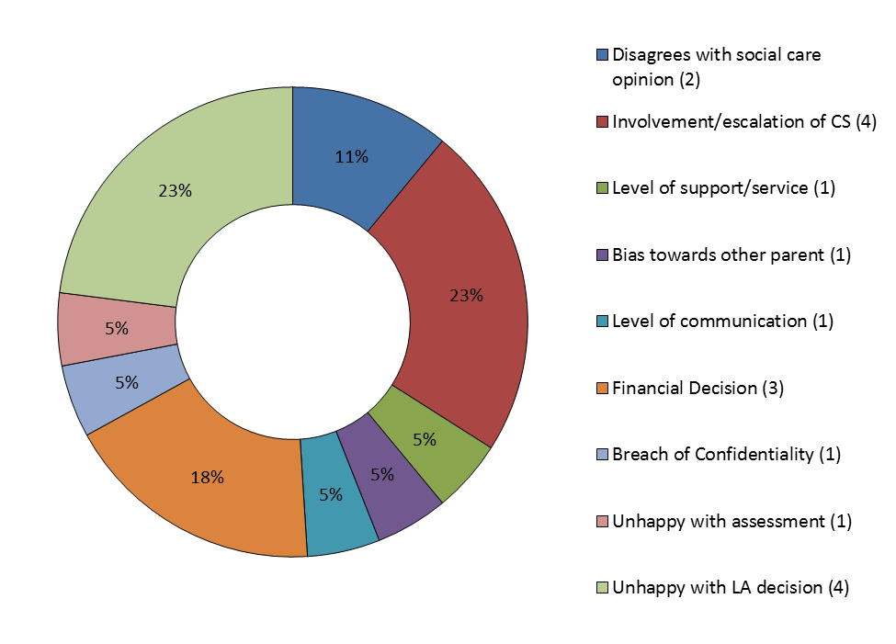  Analysis: Stage 2 complainants remained diverse in their reasoning for dissatisfaction after Stage 1. With respect to any Stage 1 complaints that may have not changed a local authority decision that the individual was unhappy with, would have likely been referred to Stage 2 to provide the individual with another opportunity for that decision to change.  With some complaints involving finance or financial support, as sometimes the requested outcome was significant (£1000.00+), it is understandable that individuals would choose another opportunity for the potential to receive such a large sum of funds/value of support.  Other complaints that did not revolve around a local authority decision or request for support of finance, would have been to do with continued protest or disapproval of Children’s Services involvement or perspective.
7 | Stage 3 Complaints:
 | There were no requests for a Stage 3 review in 2018/19
8 | Ombudsman (LGO) Complaints
8.1 | Complaints made to the LGO  Table 14
 | Service  Education and Commissioning  Children’s Social Care |  |  |  |  | No finding against Council  1  3 |  |  |  |  |  |  |  |  |  |  |  | Partial finding  0  2 |  |  |  |  |  |  |  |  |  |  | Total  1  5
The Council received six referrals/complaints from the (LGO).

While this is an increase from previous years, it has to be noted according to the figures from the LGO (from their website) about their received complaints from 2018-19, in total for Children and Education complaints they received 3196 and the London Borough of Harrow was not in the top 100 Councils by complaints received.

Of the six complaints, only three of these led to full investigations with the LGO. Three complaints that did not proceed was due to finding no fault with how the Council had considered the complaints due to:

- Being outside of complaints remit due to court process
- Local authority had already referred to individual to report to police about a criminal allegation that they wanted LA to investigate
- Local authority allowed a subsequent appeal in the case and was insufficient continuing injustice to warrant the Ombudsman’s investigation

The full investigation where the LGO found no fault with the Council was due to:

- No evidence of fault found in how the local authority dealt with a safeguarding referral

The investigations where the LGO found partial fault with the Council were due to:

- For the way it assessed a child’s needs, the way it handled a request for funding and for failing to provide clear information and advice about the post adoption support process
- Did not fully assess support needs of adoptive parents and daughter.

9 | Escalation comparison over time:  Table 15
 | 2018/19  2017/18  2016/17 |  | Stage 1  51  56  54 |  |  |  |  | Stage 2  18  7  7 |  |  |  |  |  |  |  |  |  |  |  | Stage 3  0  0  0 |  |  |  |  |  |  |  |  |  | LGO  6  1  2
 | Analysis: The escalation between the complaints stages and LGO stage over the past three years has remained low overall (keeping in mind the additional 67 representations) despite having a clear method of escalation for complainants.
10 | Remedy Payments:
A “remedy payment” is made in line with the LGO guidance on Remedy Payments. Two payments were made in 2018/19.

- £1000.00 remedy payment to a family for delay and distress.
- £1300.00 remedy payment to a family to reflect delay and distress in the case

Both these of these remedy payments were for post-adoption support cases where lessons were learned and the LGO was satisfied with the internal actions taken (discussed in section 13).

11 | Mediation and Alternative Dispute Resolution:
During 2018/19 the Complaints Team facilitated the following as mediation/ADR and to assist with reaching a resolution and preventing further formal escalation:
- Arranging and chairing a mediation meeting between an advocate, young person and the Leaving Care team to discuss his reasons for not wanting to leave his current placement. Due to the open conversation that was able to take place, a positive outcome was reached and young person was happy.
- A teleconference call between the Complaints Service and school governor to provide guidance and advice on ensuring an ongoing complaint within the school process was properly and most effectively concluded.
- Asking Leaving Care team to set up a viewing and discussion of an alternative placement for a young person so that they could consider this placement without feeling like a decision was simply being made on paper about them.
- Attending a mediation meeting between a parent, the Disability Law Centre and a Head of Service to help clarify and explain the legal position of how the local authority will consider the needs of a child with a disability with respect to the Children Act 1989.

12 | Joint NHS and social care complaints
 | During 2018/19 there was one complaint investigation carried out jointly between Harrow Council and NHS bodies. In this instance, it was with Harrow Children’s Services and Harrow Child and Adolescent Mental Health Services (CAMHS) with respect to a complaint saying a young person was not receiving the appropriate level of support.
13 | Learning Lessons/Practice Improvements
Examples of lessons learnt/practice improvements include the following:
- Significant feedback was passed on with respect to recognised gaps in securing and identifying a clear pathway for post adoption support. This was done directly with the relevant Head of Service who passed on this feedback via managers and team meetings as well as arranging training in January 2019
- To be more open for considering funding requests for (private) services not previously used/known by local authority if no alternatives are available
- Better signposting and explanation of external services or pathways of support that may fall outside of local authority services providing more of a cohesive area of support
- More detail and clearer pathway of support information should be available on our website

14 | Compliments
The majority of service users that compliment staff and the Council provide their feedback through verbal communication in care meetings or by phone.
However, both professionals who work with the local authority as well as families who use our services do write in to let us know their positive feedback and experiences. The below is correspondence received in 2018/19 and in total the below equates to around 50% of the received Stage 1 complaints, showing an excellent ratio of positive feedback to accompany received complaint numbers.
- Good morning, I was just talking to the Head at Hartsbourne Primary School in Bushey to do a welfare check and she told me that she has a number of Harrow children and: “I know how you work and I like how you work” She said that she works with three local authorities and finds Harrow by far the best LA to work with.
- This morning I was talking to a deputy head about a Brent child and she was saying that she wishes that every local authority had as good a MASH as Harrow. She said that Harrow is the only local authority where she can phone MASH and be given advice and information immediately and that her experiences with other LA’s MASH was greatly inferior to her experience with Harrow’s.
- I thought I MUST write to say how impressed with D (Children’s Social Worker) I was from our Core Group meeting on Friday. She had in short time built up a rapport with mum, who has now had 6 social workers I know of across three local authorities. D spoke with dignity to mum, empathised with mum and had already made arrangements to get the support mum needs with a very complex case and a very violent partner. D is the only social worker who has looked at how Mum can be protected and supported in making the right decisions to get herself out a vicious cycle, without judging mum and leaving her to fight a mighty battle. I was really impressed , and in light of my recent experiences in other cases we are involved in, I am very pleased. The case is a tough one, and we are all worried that if could all go sour if dad loses it, but I have confidence that mum is being understood and listened to; thank you D. (From a Primary School Headteacher)
- In coming down on the side of the local authority’s argument that reconciling the children with their mother offered the least bad option, the judge praised the family’s “sensible” and “committed” social worker. She noted the social worker’s assessment that the “risk of physical chastisement had reduced” and that there were “positive signs for the future”. https://www.communitycare.co.uk/2018/04/27/judge-rules-diplomatic-immunity-barrier-care-proceedings/
- Thank you again for all your help we really appreciate everything you have done for us…the Police will be able to carry out sporadic checks on the premises – From Community Safety Officer in reference to Children’s Head of Service chairing a multi-agency meeting for a property closure
- I am writing to you with regards to Social Worker DK. D has recently been assigned to a student in my school. From the first time D contacted me, she has been very professional and has provided a first class service to both the parent and the student. She has kept the school in the loop at all times and has gone above and beyond with regards to ensuring both parent and child’s wellbeing are met. D’s attention to details is second to none. I have thanked her numerous times, but I felt you had to be informed that you have a fantastic member of staff on your team. She is kind, professional, diligent and goes above and beyond her role as a social worker. She’s a pleasure to work with. – From Primary School Learning Mentor
- On my part it was great to see the MASH, discussed and debated at my time on the borough, fully fledged and delivering for the vulnerable in Harrow. I was instantly reminded of the positive attitude of so many in the local authority – all I spoke to were enthusiastic, committed individuals, well led and focussed. – From Retired Borough Commander
- I just wanted to relay to you the Judge’s warm compliments to the social work team in court, J and R, for the way in which they had supported the family in this case, which had led to the children being able to remain with their mother. The Judge’s praise was spontaneous and genuine The judge stated ‘I commend the Local Authority for the extensive support they have given to keep the children within the family. There is only one person who is earning money and that is the father. However, the Local Authority has sought to do all it can to provide financial and other support for the benefit of the family’ – From Senior Legal Advocate
- I am very happy with the service that has been provided to my children and myself and we have had a few very stressful years and when R was appointed to us at the end of 2017 we finally felt like we were being listened to, and she has really helped us move forward in many areas, many of these areas like housing are probably not even something that are part of her job. R has gone above and beyond for my family and we wouldn’t be as far along in rebuilding our life without her, the support that she has offered me has been amazing and as I feel I have been let down by other professionals such as my IDVA worker, she has been really appreciated during this difficult journey. We all think very highly of our social worker and I am very happy with the way our case has been handled – Parent/Service user
- Hello R
Kids are looking forward to seeing you later today. I am not sure if I will be home as I have a meeting.
Thank you for ALL your help and support during a really tough time but finally we have the outcome that we wanted. Please keep in touch and you know you will always get a huge welcome if you do drop in for a “play date” with L and J!
We were so very lucky to have you working with us and wish you all the very best for the future. Love B - Parent/Service User
- Thank you for your email and the excellent service you and your (school admissions) team have given to us over the last two months. – Parent/Service User
- Thank you ever so much for the time you have taken today to talk through our attendance procedures especially Children Missing in education. I found the way that you explained the different processes very helpful. It was very evident from our conversation this morning, that you have a wealth of information. You have given us lots of practical advice which we will implement intelligently in order to support our families and raise our attendance. – From Deputy Head
- Kenmore Park Juniors has found the work of the MASH team invaluable in our delivery of Safeguarding. In particular, the expert advice and support of individuals such as GB allow the school to fully safeguard pupils with the most complex of needs. Their timely support enhances and expands our provision for vulnerable pupils. We appreciate the many times that GB and the MASH team goes above and beyond the call of duty in order to support the school with often very complex issues. – Deputy Head
- I would like to take this opportunity to thank NL (social worker) for all of his hard work in the most difficult time of my life. I was extremely sad to see him leave us. He always replied to messages and calls quickly and anything I asked him to help me with always within the social services remit; he never failed to follow through with it. He is and exceptional part of the team and a credit to all of his managers - he is also a credit to himself for being a wonderful and caring human being. There are people in this world who are made for the work that they do and I truly believe that N is one of them. I wish him all the success in the future and have confident hope that he will help many other families the way he has helped me throughout his career. He had been my only constant / consistent source to speak to when I needed it most after going through a terrible time with my abusive partner and being diagnosed with cancer after first thinking I had lost a baby - i felt he always treated me with dignity and respect and I was never anxious or afraid to pick up the phone and talk to him about anything - A (my daughter) thought he was great too. I wish I could put more into words to explain my gratitude . *Lastly, he went above and beyond his duty bound responsibilities and it always felt like N was helping me because he truly wanted to ;not just because he was required to due to what was expected of him at work. There should be more people in the world like him. Yours kindly A – Parent/Service User
- We, as a family, knew Canons was the right school for S and I do not think that I will ever be able to convey my sincere gratitude and appreciation to the staff at Harrow Council for giving S this wonderful and privileged opportunity, which will not be wasted. Without sounding too dramatic, this has really saved S's future and his life, thank you so much again. Lastly, I would like to say a personal thank you to you too, I felt I got to know you somewhat over the last year and although there was nothing you could do except offer me advice following Harrow's guidelines, I always got a sense that you cared. You always took the time to listen, understand and offer me the various options available when I called the Admissions team and I think it is your approachability, warm, polite, patient, professional, respectful and reassuring demeanour that played a part in me pressing on with keeping S on the waiting list and appealing. Thank you N, you have been absolutely wonderful and I have really valued you. – Parent/Service User
- I just wanted to echo my thanks to you for your continued support throughout the process of helping me through choosing my school place for my daughter. Your advice, and general support around the application process made it very easy for me and my wife. I wish they were more helpful people like you. – Parent/Service User about Admissions Team
- Just want to feedback on last nights training with G. As much as I was reluctant to come out on a dark Autumn evening, after attending, I could have listened to G for another 2-3 hours! She was fantastic! The training was interactive, informative and very very interesting. Please, could you pass on my message to her and thank her for arranging this (from the request made by childminders at the 2-year progress check meeting.) In no time she arranged this to become viable and the response from other settings to attend was overwhelming! – About SEND training delivered by Early Years
- I am writing to commend one of your staff members .
J has gone above and beyond to assist us ,in obtaining a place for my niece at Pinner High School .
He is absolutely amazing and we as a family ,are extremely grateful to him .
Please pass on our sincere thanks – Re Admissions Team by Relative/Service User
- I must thank through you to the entire council team for the great job, the effortless way i got my ward's admission into my first choice school. – Parent/Service User
- A parent on the group recently complained about a short break issue so I told her you had given permission to give parents your email address (which I do but carefully). She got back to the group to say you quickly replied and she was contacted just as quickly by a short breaks provider to provide support. She was very pleased, pleasantly surprised at the sheer speed of redress and the results. I have had other parents commenting on the how great that was too.
I am writing to say; thank you, we are also very impressed and it makes our job easier when parents can experience results for themselves from the progress we know you are making behind the scenes. – Re Head of Service for CYAD from Harrow Parents 4 Disabled Children
- Thank you for your training and advice. Your enthusiasm and commitment for Early years is remarkable and no doubt it has given us a lot to think and action. My team feels the same. I will keep in touch with you, for your advise and support. I wish we all are as brave and committed as you are promoting positive outcome - About SEND training delivered by Early Years
- I recently came across this page: http://www.harrow.gov.uk/localoffer/services/local-info-advice and found it really helpful. Mainly because I'm a student in Uk, and I'm hearing impaired, so the resources are extremely valuable to someone like me. One thing I'm always trying to tell people is that one size does not fit all when it comes to students with disabilities, especially when it comes to online information for students in this community. So whenever I find something that provides value, I like to be proactive and share it with other disabled students I know. Thank you for putting that page together’.
- It was excellent. The Twilight yesterday was very purposeful. The 3 sessions were very informative! I feel like I have developed my understanding on how to support our SEN students further (and my son’s who is still waiting to be diagnosed), so thank you for organising this! Thanks for organising speakers for last night, they were excellent. I thought it was really useful twilight. It has given me a greater understanding about what the students who have hearing impairment face each day. It was so good to get a better understanding of Sofia too. Thanks for yesterday - it really was so helpful. It was very good please thank them – re SEND Training
- What a fascinating morning! Thank you so much for the invitation to visit the MASH yesterday morning. You certainly gave us an insight into the sheer scale of the operation, and the beginnings of an understanding into working of the groups. The interaction between the different agencies in the meetings is really impressive. – re School Safeguarding Lead MASH Visit
- Please find attached a letter expressing our thanks and appreciation for the support that we have received to date from you and your team, particularly from JC, our Post Adoption Support Worker. – Parents/Service Users
- Further to our conversation this week I wanted to put in writing how fantastic E (duty social worker) was when she came to Pinner Wood following a further disclosure of a CIN (SP). She was ultimately professional- calm, factual and an expert at de-escalation. I felt the situation and the child’s safety was absolutely safe in her hands. I learned a lot from listening to her speak to the child and her parents. The other SW I want to mention is DMR. Again, I feel the situations for the children in our joint care are improved by her involvement because she is a steady presence, sticks to the facts, listens to everyone, is determined to improve lives and again, is able to manage difficult scenarios. She absolutely has the children’s best interests at the heart of everything she says and does. It is a real pleasure to work with her. And- many thanks also to you G for all you do to support us teachers. It is great to have you on the end of the phone and you are always so supportive and helpful. – From Deputy Head re Children’s Services
- At a governors’ meeting at St. Teresa’s school this evening the head said, unsolicited, what a good service the school gets from Children’s Services in terms of accessibility to social workers and generally and said it was far better than she had been used to in Lambeth where she was a deputy head before coming to us. – From Harrow Councillor

15 | Equalities Information
15.1 | Equalities Information – Stage 1 Complaints
 | Table 16  Gender of Service User:  Male:  Female: |  |  |  |  |  |  |  |  |  |  |  |  |  | 2018/19  23 (45%)  28 (55%) |  |  |  |  |  |  |  |  |  |  |  |  | 2017/18  24 (44%)  30 (56%)
 | Table 17  Ethnic Origin of Service User: |  |  |  |  |  |  |  |  |  |  |  |  |  | 2018/19 |  |  |  |  |  |  |  |  |  |  |  |  | 2017/18
 | ASIAN OR ASIAN BRITISH
 | Afghanistani |  |  |  |  |  |  |  |  |  |  |  |  |  | 1 |  |  |  |  |  |  |  |  |  |  |  |  | 1
 | Bangladeshi
 | Indian |  |  |  |  |  |  |  |  |  |  |  |  |  | 6 |  |  |  |  |  |  |  |  |  |  |  |  | 3
 | Pakistani |  |  |  |  |  |  |  |  |  |  |  |  |  | 2 |  |  |  |  |  |  |  |  |  |  |  |  | 1
 | Sri Lankan |  |  |  |  |  |  |  |  |  |  |  |  |  |  |  |  |  |  |  |  |  |  |  |  |  |  | 2
 | Sri Lankan Tamil
 | Other Asian |  |  |  |  |  |  |  |  |  |  |  |  |  | 4 |  |  |  |  |  |  |  |  |  |  |  |  | 9
 | BLACK/BLACK BRITISH
 | African |  |  |  |  |  |  |  |  |  |  |  |  |  | 4 |  |  |  |  |  |  |  |  |  |  |  |  | 4
 | Caribbean |  |  |  |  |  |  |  |  |  |  |  |  |  | 11 |  |  |  |  |  |  |  |  |  |  |  |  | 5
 | Somali
 | Other Black |  |  |  |  |  |  |  |  |  |  |  |  |  | 2 |  |  |  |  |  |  |  |  |  |  |  |  | 4
 | OTHER ETHNIC GROUP
 | Arab |  |  |  |  |  |  |  |  |  |  |  |  |  | 3
 | Chinese
 | Iranian
 | Iraqi
 | Kurdish
 | Lebanese
 | Other Ethnic Group |  |  |  |  |  |  |  |  |  |  |  |  |  | 3
 | MIXED
 | White & African |  |  |  |  |  |  |  |  |  |  |  |  |  |  |  |  |  |  |  |  |  |  |  |  |  |  | 2
 | White & Caribbean |  |  |  |  |  |  |  |  |  |  |  |  |  |  |  |  |  |  |  |  |  |  |  |  |  |  | 1
 | White & Asian |  |  |  |  |  |  |  |  |  |  |  |  |  |  |  |  |  |  |  |  |  |  |  |  |  |  | 3
 | Other Mixed |  |  |  |  |  |  |  |  |  |  |  |  |  | 2 |  |  |  |  |  |  |  |  |  |  |  |  | 6
 | WHITE
 | Albanian |  |  |  |  |  |  |  |  |  |  |  |  |  |  |  |  |  |  |  |  |  |  |  |  |  |  | 1
 | British |  |  |  |  |  |  |  |  |  |  |  |  |  | 9 |  |  |  |  |  |  |  |  |  |  |  |  | 7
 | Irish
 | Gypsy/Roma Traveller
 | Irish Traveller
 | Polish
 | Romanian |  |  |  |  |  |  |  |  |  |  |  |  |  | 1
 | Serbian
 | Other White |  |  |  |  |  |  |  |  |  |  |  |  |  | 1 |  |  |  |  |  |  |  |  |  |  |  |  | 5
 | PREFER NOT TO SAY/NOT KNOWN |  |  |  |  |  |  |  |  |  |  |  |  |  | 3 |  |  |  |  |  |  |  |  |  |  |  |  | 2
 | Table 17 Origin of Complaints |  |  |  |  |  |  |  |  |  |  |  |  |  | 2018/19 |  |  |  |  |  |  |  |  |  |  |  |  | 2017/18
 | Service User (Young Person) |  |  |  |  |  |  |  |  |  |  |  |  |  | 5 |  |  |  |  |  |  |  |  |  |  |  |  | 4
 | Parent/relative |  |  |  |  |  |  |  |  |  |  |  |  |  | 41 |  |  |  |  |  |  |  |  |  |  |  |  | 49
 | Advocate |  |  |  |  |  |  |  |  |  |  |  |  |  | 4 |  |  |  |  |  |  |  |  |  |  |  |  | 3
 | Solicitor |  |  |  |  |  |  |  |  |  |  |  |  |  | 1 |  |  |  |  |  |  |  |  |  |  |  |  | 0
 | Friend/other |  |  |  |  |  |  |  |  |  |  |  |  |  | 0 |  |  |  |  |  |  |  |  |  |  |  |  | 0
15.2 | Equalities Information – Stage 2 Complaints
 | Table 19  Gender of Service User:  Male:  Female: |  |  |  |  |  |  |  |  |  |  |  |  |  | 2018/19  8(44%)  10(66%) |  |  |  |  |  |  |  |  |  |  |  |  | 2017/18  4 (57%)  3 (43%)
 | Table 20  Ethnic Origin of Service User: |  |  |  |  |  |  |  |  |  |  |  |  |  | 2018/19 |  |  |  |  |  |  |  |  |  |  |  |  | 2017/18
 | Sri Lankan |  |  |  |  |  |  |  |  |  |  |  |  |  |  |  |  |  |  |  |  |  |  |  |  |  |  | 1
 | African |  |  |  |  |  |  |  |  |  |  |  |  |  | 2 |  |  |  |  |  |  |  |  |  |  |  |  | 1
 | Other Black
 | Mixed Background - Other |  |  |  |  |  |  |  |  |  |  |  |  |  |  |  |  |  |  |  |  |  |  |  |  |  |  | 1
 | Other Asian |  |  |  |  |  |  |  |  |  |  |  |  |  | 1
 | Caribbean |  |  |  |  |  |  |  |  |  |  |  |  |  | 4 |  |  |  |  |  |  |  |  |  |  |  |  | 1
 | White British |  |  |  |  |  |  |  |  |  |  |  |  |  | 6 |  |  |  |  |  |  |  |  |  |  |  |  | 1
 | Unknown |  |  |  |  |  |  |  |  |  |  |  |  |  | 2 |  |  |  |  |  |  |  |  |  |  |  |  | 2
 | Arab |  |  |  |  |  |  |  |  |  |  |  |  |  | 1
 | Chinese |  |  |  |  |  |  |  |  |  |  |  |  |  | 1
 | Indian |  |  |  |  |  |  |  |  |  |  |  |  |  | 1
 | Total |  |  |  |  |  |  |  |  |  |  |  |  |  | 18 |  |  |  |  |  |  |  |  |  |  |  |  | 7
 | Table 21  Origin of Complaints |  |  |  |  |  |  |  |  |  |  |  |  |  | 2018/19 |  |  |  |  |  |  |  |  |  |  |  |  | 2017/19
 | Service User
 | Parent/relative |  |  |  |  |  |  |  |  |  |  |  |  |  | 17 |  |  |  |  |  |  |  |  |  |  |  |  | 7
 | Advocate |  |  |  |  |  |  |  |  |  |  |  |  |  | 1
 | Solicitor

16. The Complaints Process explained:

This report provides information about complaints made during the twelve months between 1 April 2018 and 31 March 2019 under the complaints and representations procedures established through the Representations Procedure (Children) Regulations 2006, and the Council’s corporate complaints procedure.

All timescales contained within this report are in working days. Text in quotation marks indicate direct quotations from the 2006 Regulations or Guidance unless otherwise specified.

16.1 What is a Complaint?

“An expression of dissatisfaction or disquiet in relation to an individual child or young person, which requires a response.”

However,

“The Children Act 1989 defines the representations procedure as being for ‘representations (including complaints)’.”

Therefore both representations and complaints should be managed under the complaints procedure (unlike for Adult social services, where only complaints need be captured).

16.2 Who can make a Complaint?

The child or young person receiving or eligible to receive services from the Council or their representative e.g. parent, relative, advocate, special guardian, foster carer, etc:

“The local authority has the discretion to decide whether or not the representative is suitable to act in this capacity or has sufficient interest in the child’s welfare.”

  - What the complaints team do:

• Letter-vetting
• Liaising with services to try resolve the issue informally
• Mediation
• Training
• Raising awareness / staff surgeries
• Learning facilitation and agreed actions monitoring
• Deliver a unique complaints support SLA to schools
• Advocacy commissioning and support

16.4 Stages of the Complaints Procedure

The complaints procedure has three stages:

Stage 1: This is the most important stage of the complaints procedure. The Service teams and external contractors providing services on our behalf are expected to resolve as many complaints as possible at this initial point.

The Council’s complaints procedure requires complaints at stage 1 to be responded to within ten working days (with an automatic extension to a further ten days where necessary).

Stage 2: This stage is implemented where the complainant is dissatisfied with the findings of stage 1. Stage 2 is an investigation conducted by an independent external Investigating Officer for all statutory complaints and an internal senior manager for corporate complaints. A senior manager adjudicates on the findings.

Under the Regulations, the aim is for stage 2 complaints falling within the social services statutory complaints procedures to be dealt within 25 days, although this can be extended to 65 days if complex.

Stage 3: The third stage of the complaints process is the Review Panel under the statutory procedure. Under the corporate complaints process, there is no Stage 3. This panels remit is not to reinvestigate the complaint.

Where complainants wish to proceed with complaints about statutory Children’s Services functions, the Council is required to establish a complaints Review Panel. The panel makes recommendations to the Corporate Director who then makes a decision on the complaint and any action to be taken. Complaints Review Panels are made up of three independent panellists. There are various timescales relating to stage 3 complaints. These include:

• setting up the Panel within 30 working days;
• producing the Panel’s report within a further 5 working days; and
• producing the local authority’s response within 15 working days.

Local Government Ombudsman

The Ombudsman is an independent body empowered to investigate where a Council’s own investigations have not resolved the complaint.

The person making the complaint retains the right to approach the Local Government Ombudsman at any time. However, the Ombudsman’s policy is to allow the local authority to consider the complaint and will refer the complaint back to the Council unless exceptional criteria are met.

Section 3 - Statutory Officer Clearance
The Corporate Director determined the report did not require Financial or Legal clearance.

Section 4 - Contact Details and Background Papers
Contact: Usman Zia, Complaints Manager, Adults & Children’s Complaints, 020 8424 1627
Background Papers:
None

The total of representations, Stage 1, Stage 2, Stage 3, member enquiries & LG Ombudsman referrals within Children and Families Services.
Please note any reference to “Targeted Services” in previous reports is in reference to Children’s Social Care Teams and these terms are interchangeable throughout these reports and refer to the same services.

